Package Diagram
Package diagrams are structural diagrams used to show the organization and arrangement of various model elements in the form of packages. A package is a grouping of related UML elements, such as diagrams, documents, classes, or even other packages. Each element is nested within the package, which is depicted as a file folder within the diagram, then arranged hierarchically within the diagram.

Basic components of a package diagram
The makeup of a package diagram is relatively simple. Each diagram includes only two symbols:
Symbol Image | Symbol Name | Description
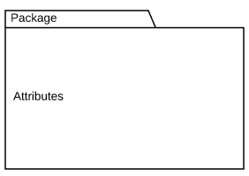 | Package | Groups common elements based on data, behavior, or user interaction
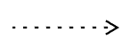 | Dependency | Depicts the relationship between one element (package, named element, etc) and another

Package diagram example
Take a look at the following template to see how a package diagram models the packages within a basic e-commerce web app. Click on the template to modify it and explore how you can show the structure of any designed system at a package level.

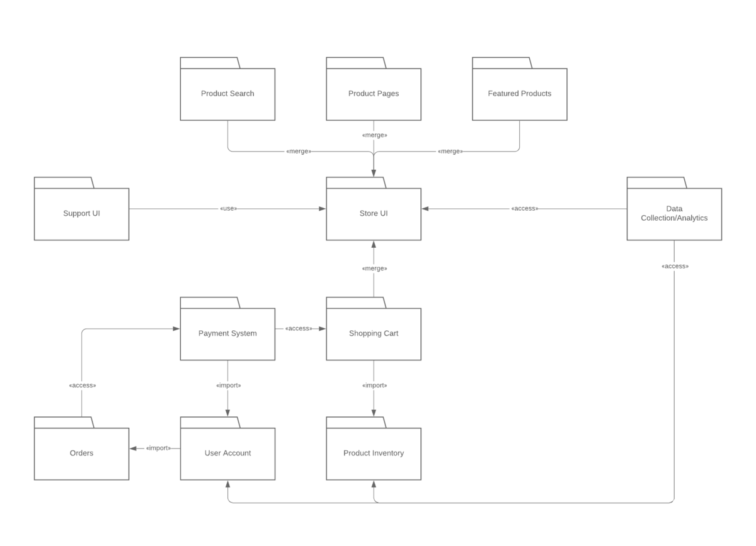

Object Diagram
A UML object diagram represents a specific instance of a class diagram at a certain moment in time.
An object diagram focuses on the attributes of a set of objects and how those objects relate to each other.

Object diagram elements
Object diagrams are simple to create: they're made from objects, represented by rectangles, linked together with lines. Take a look at the major elements of an object diagram.

Objects
Objects are instances of a class. For example, if "car" is a class, a 2007 Nissan Altima is an object of a class.

Class titles
Class titles are the specific attributes of a given class. In the family tree object diagram, class titles include the name, gender, and age of the family members.

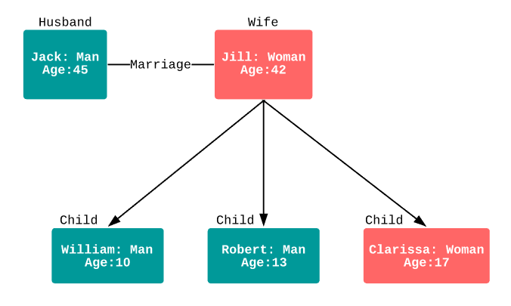
The corporate object diagram below shows how departments are connected in the traditional organizational chart style.
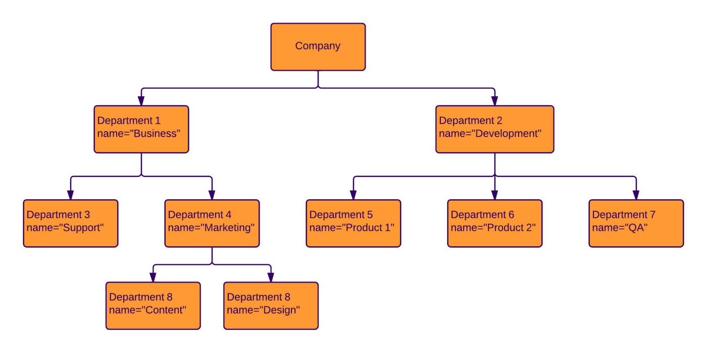

Sequence Diagram
To understand what a sequence diagram is, it's important to know the role of the Unified Modeling Language, better known as UML. UML is a modeling toolkit that guides the creation and notation of many types of diagrams, including behavior diagrams, interaction diagrams, and structure diagrams.
A sequence diagram is a type of interaction diagram because it describes how—and in what order—a group of objects works together. These diagrams are used by software developers and business professionals to understand requirements for a new system or to document an existing process. Sequence diagrams are sometimes known as event diagrams or event scenarios.
A hospital information system, also known as a hospital information system, helps doctors, administrators, and hospital staff managing all of the activities and information collected at a hospital, including checkups, prescriptions, appointments, and information on the patients and their caretakers. The diagram below provides a simple view of how the primary processes operate with each other over time.
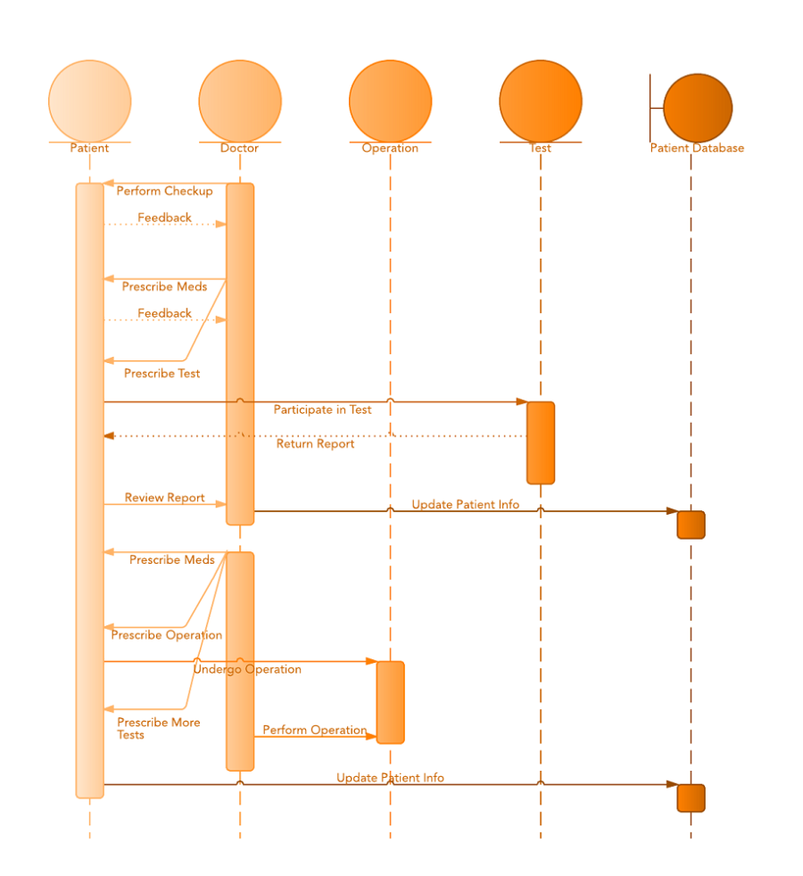

Sequence diagram for ATM systems
An ATM allows patrons to access their bank accounts through a completely automated process. You can examine the steps of this process in a manageable way by drawing or viewing a sequence diagram. The example below outlines the sequential order of the interactions in the ATM system.

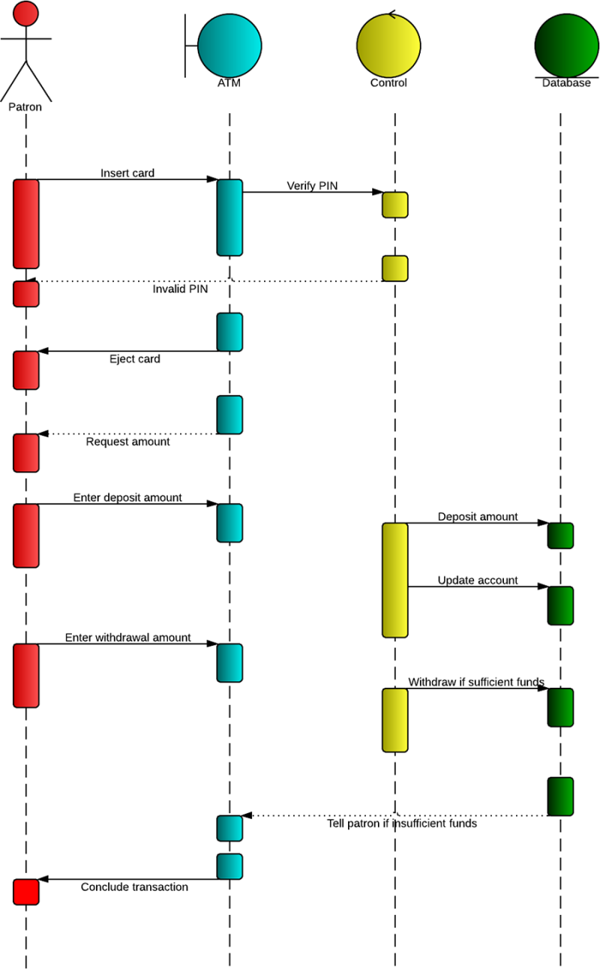
EXAMPLE QUESTION: To give an exam, an instructor first notifies the students of the exam date and the material to be covered. She then prepares the exam paper (with sample solutions), gets it copied to produce enough copies for the class, and hands it out to students on the designated time and location. The students write their answers to exam questions and hand in their papers to the instructor. The instructor then gives the exam papers to the TAs, along with sample solutions to each question, and gets them to mark it. She then records all marks and returns the papers to the students.
Draw a sequence diagram that represents this process. Make sure to show when is each actor participating in the process. Also, show the operation that is carried out during each interaction, and what its arguments are. (10 Marks)

